Datatables Document:

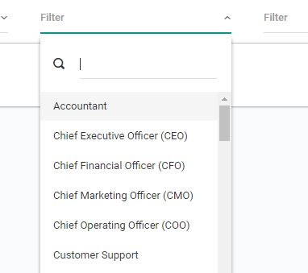

* 1.To create this search filter.

1. Added class sel2Filter to select filter on Line no 265 to identify individual Filter.
2. Called select2 constructor function to create select2 elements on line no. 294.

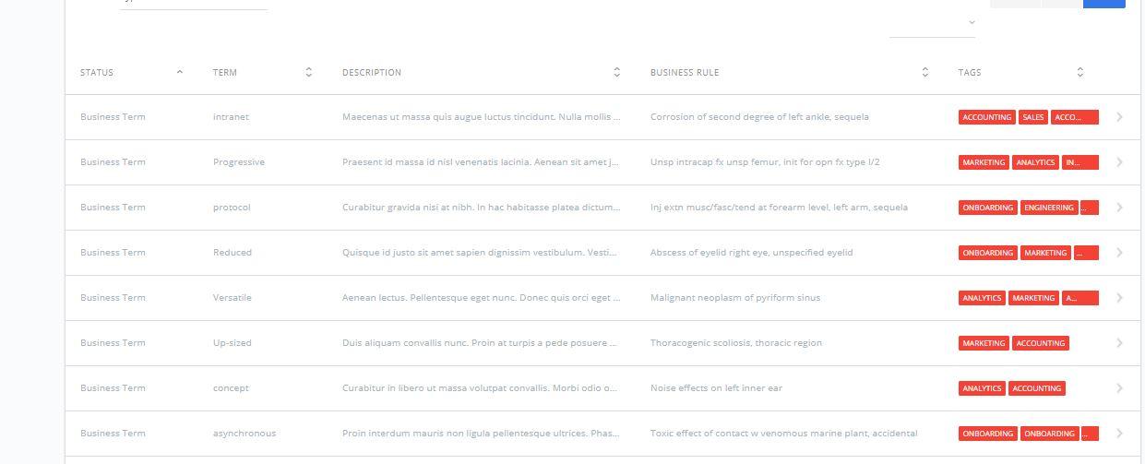

* To add tags to tag column.

1. Added render function to update ajax data with label danger to get tags needed.

* To get missing column filter on hidden columns.

1.Wrote a function on line no. 249 to render all individual column filters when hide/show event get fired.